The Great Water Cycle

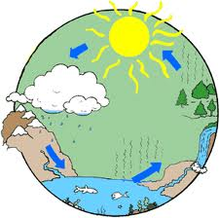 Sekuan Modibo

Derrick Murphy

Table of Contents:

Getting Started ………………………………..3

System Requirement ………………………..4

Basic Use …………………………………………5

Troubleshooting……………………………….8

Product Overview:

The Great Water Cycle is an interactive tutorial that will help users have a better understanding of what happens during the hydrologic cycle! During this tutorial users will learn new vocabulary and have a visual understanding of what occurs.

System Requirements:

One of the following Internet Browsers

* Internet Explorer
* Google Chrome
* Safari
* Mozilla Firefox

[](http://www.google.com/imgres?imgurl=http://www.rocketroute.com/wp-content/uploads/browser-icons.png&imgrefurl=http://www.rocketroute.com/support/browsers&h=191&w=685&tbnid=Ri-QUij-TJyzHM:&zoom=1&docid=5dpvBqj-PwocKM&ei=Fy0PVNiMNdi8ggTn64DACA&tbm=isch&ved=0CJ8BEDMoYjBi&iact=rc&uact=3&dur=951&page=3&start=68&ndsp=38)

Basic Use

1. Launch internet browser.
2. In the search bar enter.

<http://scratch.mit.edu/>

1. Click the **Explore** tab located on the top of the web page.

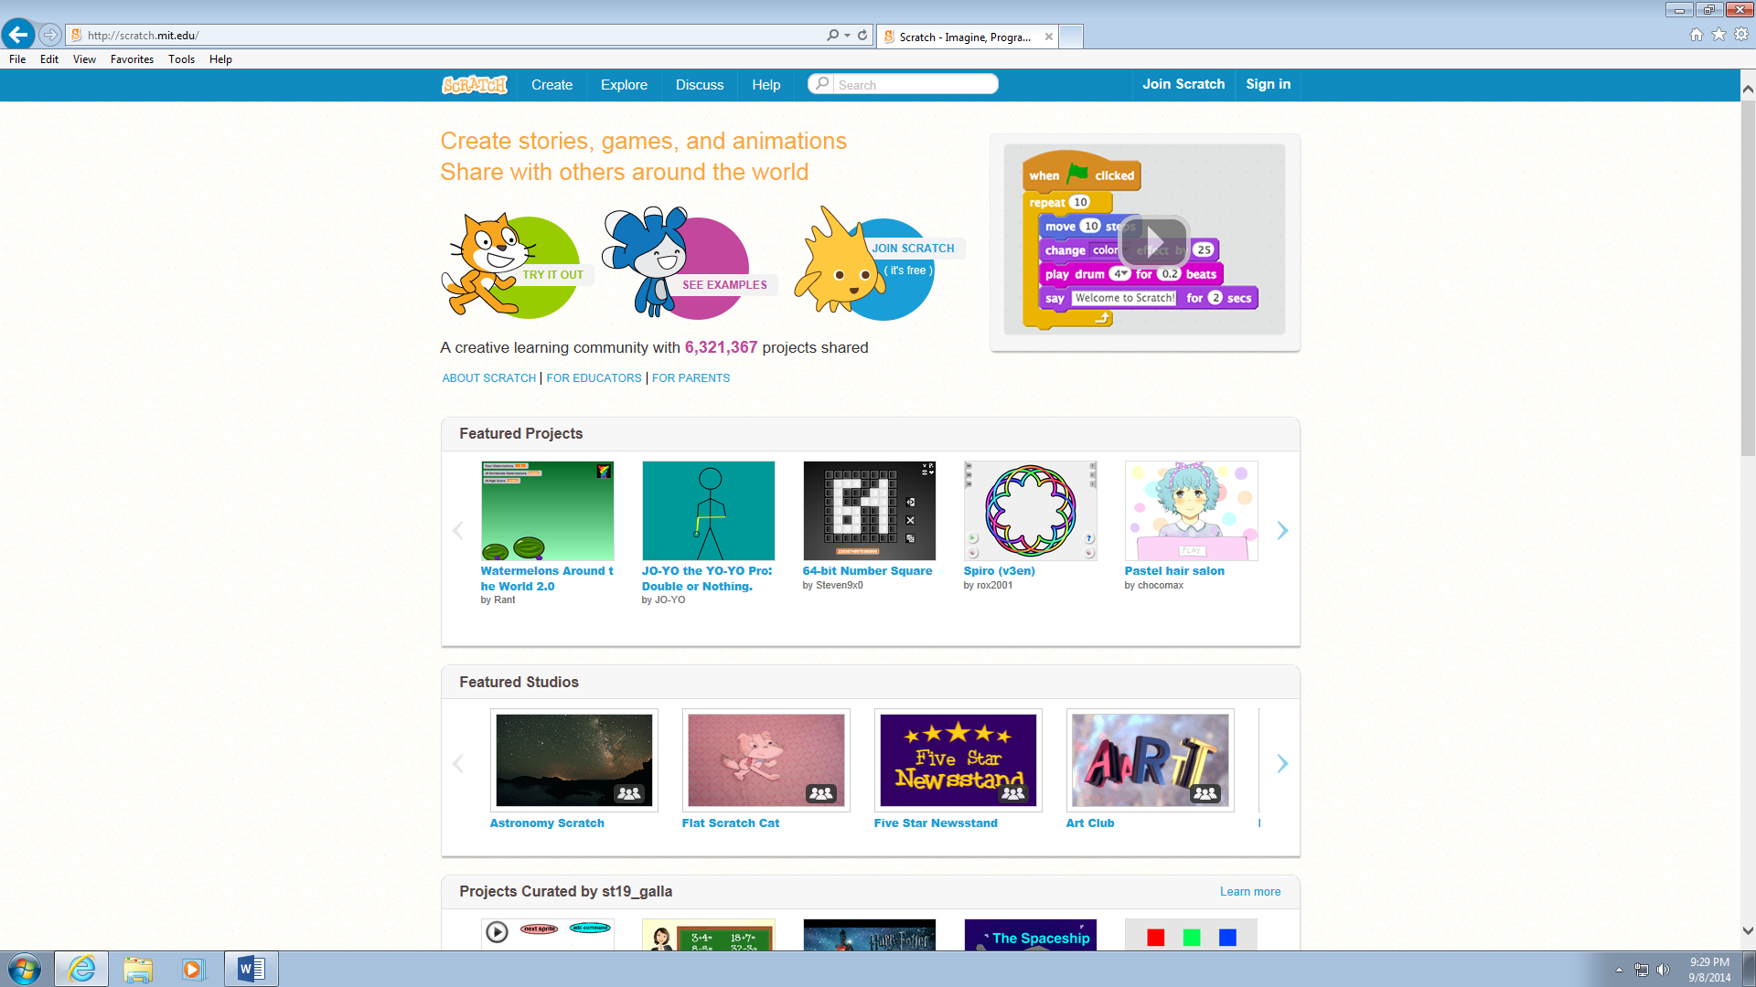

1. In the Tag search box on the left side type **Cycle** and click **Go**.

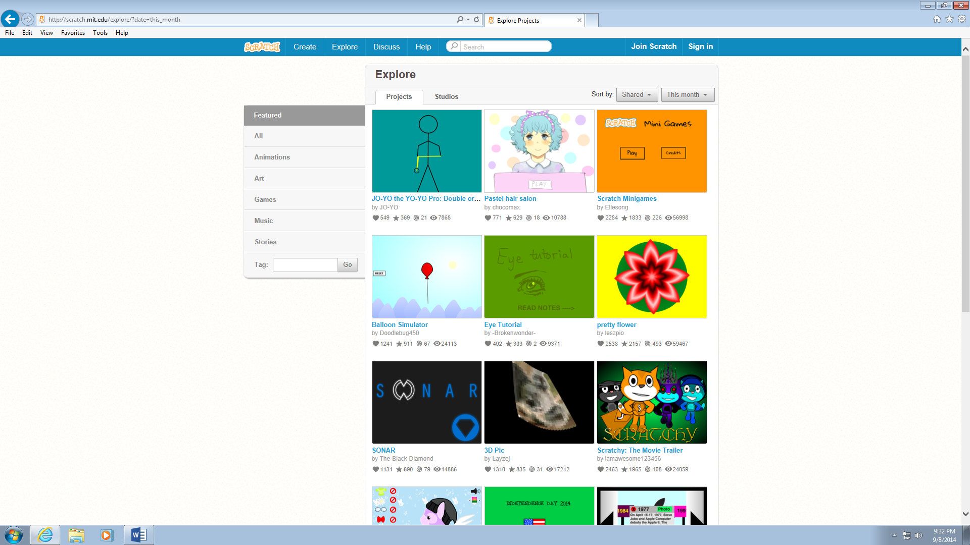

1. 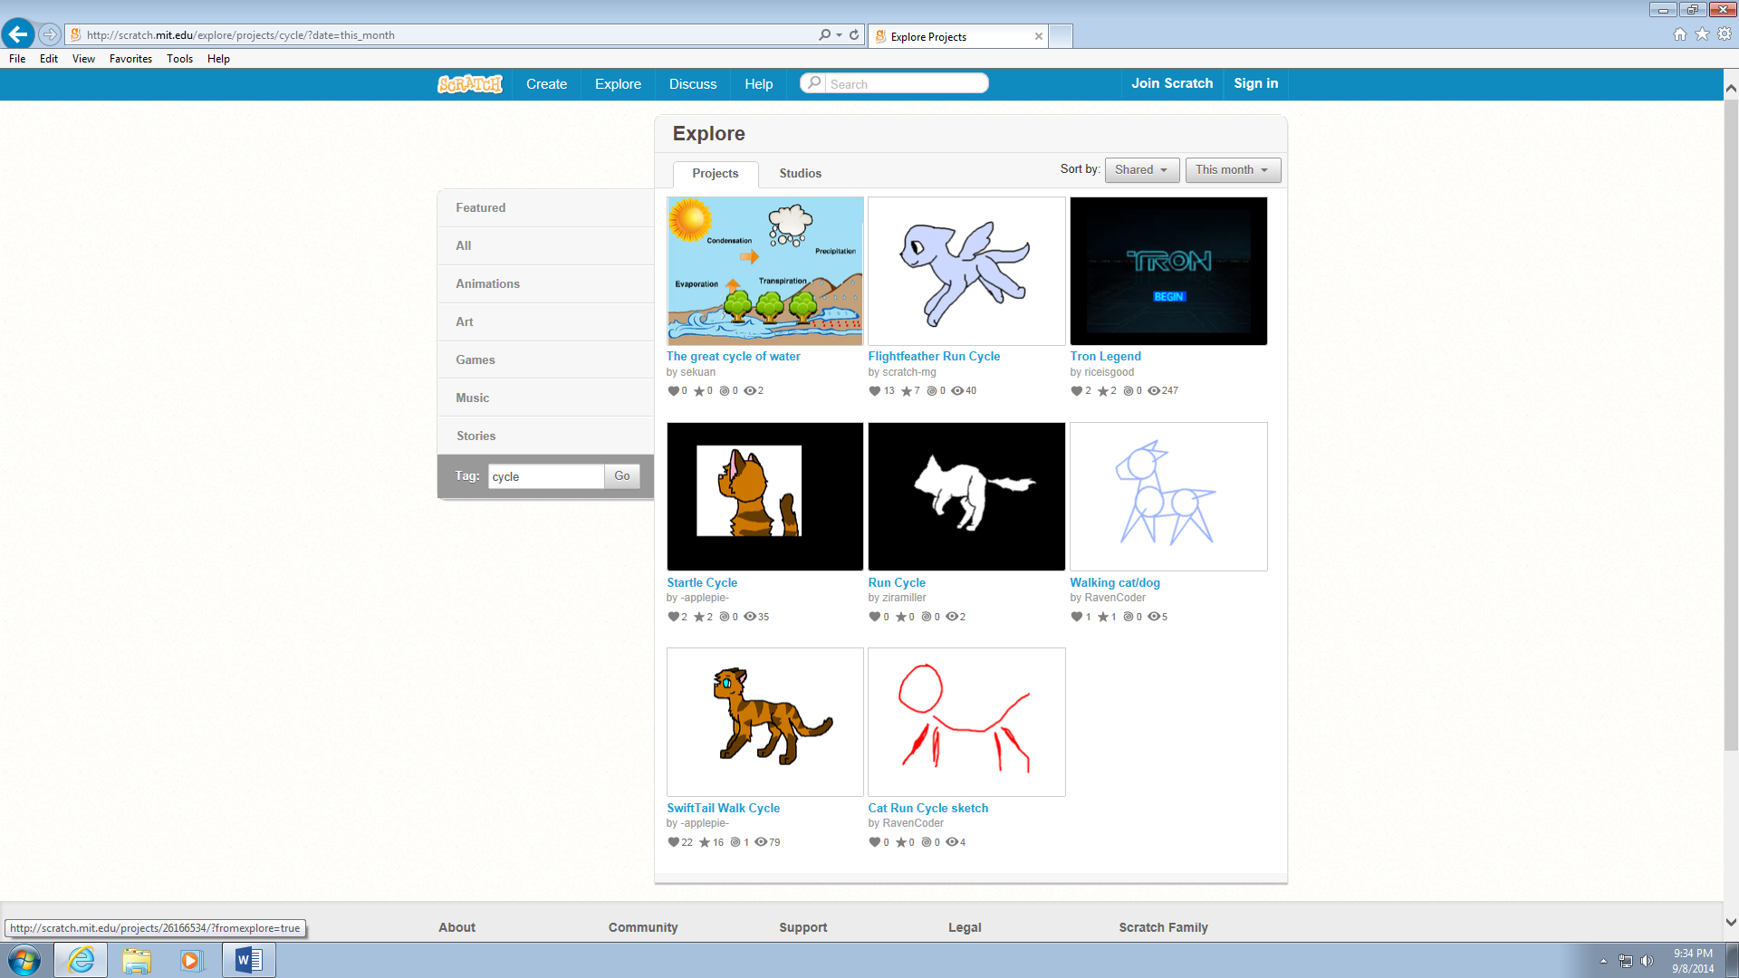Click **The Great Water Cycle.**
2. Click **Green flag** to begin the tutorial.

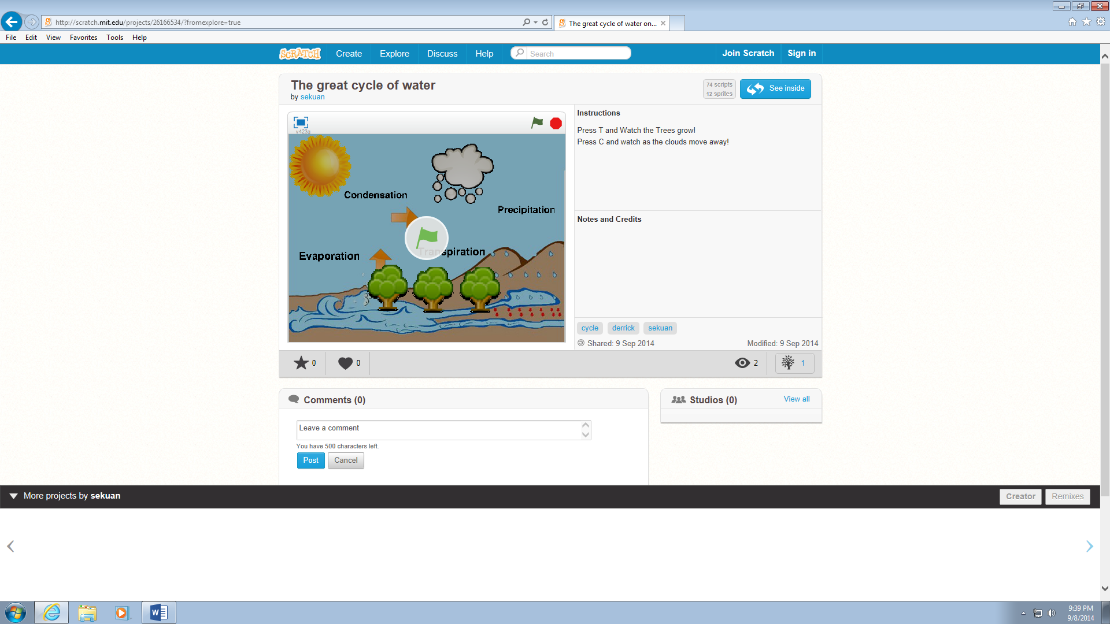

Enjoy!

Troubleshooting:

If web browsers freeze

* Insure internet connection.
* Press the F5 key to refresh the web page.
* Restart web browser.